Manuscript intended for Methods in Ecology and Evolution

NestNetR: Deep-learning based analysis of breeding behaviour from light and temperature recordings in R

Bennett Paul Stolze ^{1,2} & Simeon Lisovski ¹

¹ Alfred Wegener Institute, Helmholtz Centre for Polar and Marine Research, Polar Terrestrial Systems, Potsdam, Germany
² University of Potsdam, Institute of Biochemistry and Biology, Potsdam, Germany

Abstract
- Quantifying breeding behaviour in migratory birds is essential for understanding how species respond to rapid environmental change, particularly in the Arctic where warming is most pronounced and field observations are limited.
- NestNetR is an open-source R package that automates the analysis of avian breeding behaviour from light-level geolocator data using deep learning. The package integrates data preprocessing, model definition, and behavioural classification through convolutional neural networks (CNNs) implemented using Keras and TensorFlow, providing a reproducible and modular workflow.
- To demonstrate its application, we trained a CNN on long-term geolocator data from Ruddy Turnstones (Arenaria interpres), an Arctic-breeding shorebird. The model achieved high predictive accuracy (micro F1-score = 0.92 ± 0.01), effectively distinguishing incubation, brooding, and non-breeding activity from combined light and temperature time series.
- NestNetR offers an accessible framework for inferring breeding behaviour from biologger data, reducing manual effort and observer bias. It extends the use of light-level geolocators beyond migration research and facilitates large-scale, objective analyses of avian breeding behaviour.

Key-words: bird migration, geolocation, deep learning, breeding behaviour

Introduction
Changes in behavioural patterns of migratory birds, particularly breeding activities, provide critical insights into how individuals and populations are affected by and adjust to changing environmental conditions, ultimately determining reproductive success (Both et al., 2009; Visser et al., 2004). These effects are especially evident in polar regions, where climate warming is progressing faster than anywhere else on Earth (IPCC, 2023; Serreze & Barry, 2011). In this region, Arctic-breeding birds rely on a narrow seasonal window for reproduction, making them highly sensitive to local climatic conditions and the timing of resource availability (Lameris et al., 2017; Liebezeit et al., 2014; Post et al., 2009). Missing these seasonal peaks in food availability can reduce individual fitness (van Gils et al., 2016), reproductive success (Carey, 2009; Lameris et al., 2018), and may ultimately contribute to population-level declines unless individuals are able to adjust to the novel conditions (Both et al., 2006, 2009). Quantifying behavioural changes across years and populations is therefore key to understanding how environmental change shapes population dynamics. However, direct observation of breeding activities in these remote regions remains logistically challenging, limiting our ability to assess how environmental change affects reproductive performance in the wild (Burger et al., 2012; Lisovski, 2018).
Biologging technologies are increasingly used to address these challenges, with light-level geolocators providing information not only on migration but also on breeding activities through recorded light and temperature data in remote Arctic habitats (Burger et al., 2012; Gosbell et al., 2012; Huang et al., 2021; Lisovski et al., 2016; Loktionov et al., 2015; Schaub et al., 2019). Because these loggers are typically attached to the bird’s leg, they record local light exposure and temperature close to the surface. In Arctic breeding environments, characterised by continuous daylight and the absence of twilight, small fluctuations in light intensity and temperature can be used to infer behavioural states at the nest (Bulla et al., 2016; Burger et al., 2012; Gosbell et al., 2012; Lisovski et al., 2016). With its growing availability through different repositories for biological data, researchers now have unprecedented opportunities to investigate these processes at population scales (Lisovski et al., 2024; Nathan et al., 2022). However, manual identification of behavioural states is labour-intensive and often highly subjective, limiting comparability across studies. This lack of a consistent, objective definition of breeding behaviour hampers the integration of results across species and regions, highlighting the need for automated and standardised analytical approaches. To overcome these limitations, automated classification methods using machine learning approaches are increasingly being explored in ecology, offering objective and scalable solutions for behavioral analysis (Keitt & Abelson, 2021; Nathan et al., 2022).
Building on these advances, deep learning represents a specialised and increasingly powerful method for objective analysis of complex ecological time-series (Borowiec et al., 2022; Brodrick et al., 2019). Here, we present a tool and workflow that applies a deep neural network to classify three breeding states – incubation, brooding and non-breeding activities – from geolocator-derived light and temperature time series. We demonstrate the workflow using a long-term dataset of the Ruddy Turnstones (Arenaria interpres), a long-distance migratory shorebird breeding in the high Arctic. This system provides an illustrative example of how deep learning can be used to analyse breeding behaviour from light and temperature recordings, particularly under Arctic conditions where continuous daylight and limited field access make conventional behavioural monitoring challenging. Overall, the workflow aims to establish a consistent, data-driven framework for identifying breeding behaviour from biologger time series, enabling reproducible inference across individuals, populations, and years, and demonstrating the potential of deep learning for automated ecological analyses.

R–package NestNetR

Overview
NestNetR is an R package developed to identify and classify avian breeding behaviour from time series of light intensity and, if available, temperature measurements using deep learning. The package provides a complete and reproducible, 3-step workflow that integrates data preprocessing, model training, and automated behavioural classification using the trained model. Breeding states are inferred using a convolutional neural network (CNN), which is well suited for detecting characteristic temporal structures across multiple scales via so-called stacked one-dimensional convolutional and pooling operations (QUELLE). Models are implemented in R via Keras with a TensorFlow backend, which together provide open-source libraries for defining, training and deploying deep neural networks within the R environment (Chollet & et al., 2015; Kalinowski et al., 2025).
The resulting model distinguishes three categories of breeding behaviour: incubation, brooding, and random (unclassified) activities. Incubation is characterised by extended periods of elevated and stable temperature and low or absent light, reflecting continuous nest attendance (Gosbell et al., 2012). Brooding consists of shorter, more frequent temperature drops and light increases caused by parental exchanges and chick care (Loktionov et al., 2015), while random activity represents irregular temperature–light dynamics typical of non-breeding states such as foraging or resting.
Table 1 – Description of functions available in the NestNetR package
Function name | Description | Category
read_light | Reads and parses raw light-intensity data from biologgers, returning timestamps and log-transformed, normalised light values. | input
read_deg | Reads temperature data from .deg files and returns daily minimum (Tmin) and maximum temperatures (Tmax).
set_breeding_period | Determines the breeding-period range (start & end) either automatically from twilight files or manually through an interactive selection tool. | preprocessing
Preprocessing | Cleans, rescales and segments biologger data (light, Tmin, Tmax) into standardised windows for model input.
create_breeding_data_list | Automates the full data preparation workflow across multiple individuals, combining reading, trimming and segmentation.
create_trainingdata | Opens an interactive GUI to manually label randomly chosen segments from all available individuals as incubation, brooding or random for model training. | training data
classify_breeding_behaviour | Applies either a pre-trained CNN model or a costumly designed model to classify breeding behaviour per segment and outputs predicted probabilities and labels. | application

Step 1: Preprocessing of input data
The preprocessing workflow in NestNetR prepares raw light-level geolocator data for behavioural classification by converting input variables into a uniform, model-ready time-series format. The functions read_lux and read_deg automatically import files in supported formats (e.g. .lux, .deg). In most cases, these files are stored as text and can alternatively be read into R using the base function read.table.
Because raw data typically cover the entire migration cycle of an individual, the dataset must first be trimmed to the breeding period by using the set_breeding_period function, which identifies the start and end of the Arctic breeding phase either automatically, based on an additional available twilight file (.twl, auto = TRUE; s. GeoLight package by Lisovski & Hahn, 2012, or TwGeos package by Wotherspoon et al., 2016), or manually through user selection in an interactive tool (auto = FALSE).
Within the defined breeding period, the preprocessing function assembles and segments biologger data into model-ready inputs. For this, the function first sub-sets all available variable records to the length breeding window. Here, light data serve as the reference timeline, and all additional variables – typically recorded at lower temporal resolution – are interpolated to match this scale within their respective sampling interval. The data are then segmented into temporal windows according to user-defined parameters for segment length (e.g. one, two, or more days) and potential overlap (e.g. zero days to one day). Each segment is stored as a separate list element containing variable data for that period. To ensure comparability between variables, all input channels are scaled to a range of 0 to 1 after clipping values outside the 2.5th–97.5th percentile range, identifying realistic value ranges and minimising the influence of extreme outliers.

Step 2: Model definition (optional)
NestNetR provides the option for users to either apply a pre-trained base model (developed using Ruddy Turnstone data with one-day input windows) or define a custom model. If the pre-trained model is used, this step can be omitted. The workflow presented here follows the structure of the base model but allows full flexibility in the selection of window length, input variables, model architecture, and training strategy. Model definition is implemented using functions from the keras3 package (Kalinowski et al., 2025).

Step 3: Model application
Using the classify_breeding_behaviour function in NestNetR, users can either apply the integrated Ruddy Turnstone model or use a custom-trained model from the previous step. The function takes preprocessed data and a trained keras neural network model as input to classify breeding behaviour for the specified breeding period. For each time step, the model assigns one of the three behavioural categories (incubation, brooding, random) based on the class probabilities produced by the network.
The output includes both a complete time series of daily classifications. These results allow users to infer key breeding parameters directly from geolocator data and to compare behavioural timing and breeding success across individuals or populations.

Ruddy Turnstone model

Overview of the Dataset
To demonstrate the applicability of our workflow under realistic ecological conditions, we used data from Ruddy Turnstones (Arenaria interpres) – a long-distance migratory shorebird whose Arctic breeding ecology exemplifies many of the outlined challenges. The dataset comprises geolocator records since 2009, resulting in 372 individual tracks from birds of two populations (King Island, Tasmania and the southeast mainland, covering multiple locations in South Australia and Victoria).
Ruddy Turnstones predominant breeding areas in eastern Siberia are extremely remote and thus challenging to access, while concerns over disturbing this largely undisturbed region further limit opportunities for direct observation. These characteristics make the species a suitable case for testing indirect, data-based approaches to behavioural classification.
Ruddy Turnstones are among the earliest shorebird species to initiate breeding after arrival in the Arctic and typically exhibit biparental incubation, with both parents alternating bouts of continuous nest attendance (Cramp et al., 1983; Gosbell et al., 2012; Nettleship, 1973; Parmelee & MacDonald, 1960). These alternating on- and off-nest phases create consistent temporal patterns in light and temperature recordings that reflect breeding behaviours such as incubation and brooding (Gosbell et al., 2012; Lisovski et al., 2016).

Neural Network Architecture
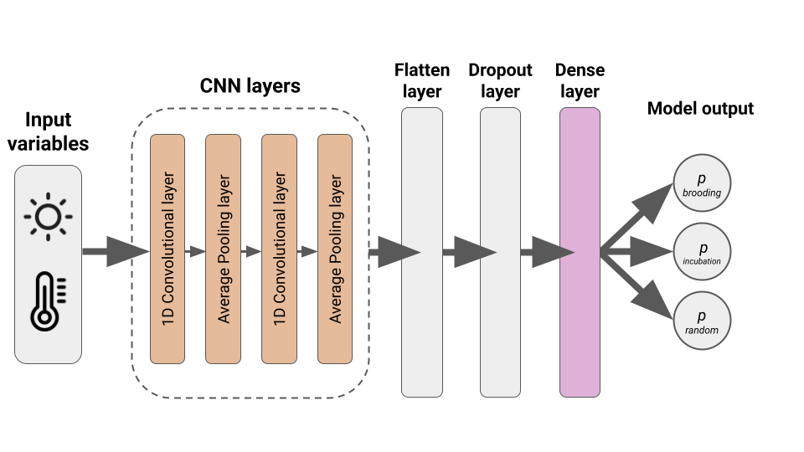
Figure 1 – Schematic overview of the architecture of the developed convolutional neural network (CNN). The model gets time series inputs of light intensity (lux) and temperature (maximum and minimum) derived from light-level geolocators. Initial 1D convolutional and pooling layers extract local temporal features across the standardised 24-hour samples. Flatten and dropout layers are followed by dense layers, transforming the learned representations into probability scores for each of the three behavioral classes: ‘incubation’, ‘brooding’, and ‘random’ (non-breeding activities).
The final convolutional neural network (CNN; s. Fig. 1) architecture consists of an input layer receiving three channels (Light, Tmin, Tmax) with a fixed window length of 288 time steps (corresponding to 24 hours at 5-min intervals). Light data were log-transformed prior to rescaling to enhance the representation of low-light variation. To identify the most suitable model, multiple neural network architectures and structural settings were compared during model development (s. Supplementary material A). This included systematic adjustments of key hyperparameters (e.g. number of filters, kernel size, and dropout rate), different composition of variables, varying sizes of training data (10 – 100%) and alternative distributions of behavioural classes within the training data (equal, …). These comparative tests formed the basis for selecting the final convolutional neural network architecture applied in subsequent analyses.
Optimal hyperparameters of the model were determined through a tuning procedure implemented in the kerastuneR package (Abdullayev, 2024). A custom model-building function was defined to explore combinations of key architectural components, including the number of filters (32–480, step size = 16) and kernel sizes (2–20, step size = 2) in the convolutional layers, pooling sizes (4–20, step size = 2), dropout rates (0.1–0.5, step size = 0.1), and dense layer units (128–480, step size = 16). Optimisation was performed using Hyperband tuning (Li et al., 2018), which adaptively allocates computational resources to the most promising configurations. Three Hyperband iterations were conducted, and performance was evaluated using micro F1-score to identify the most robust and generalisable model parameters.
Two consecutive one-dimensional convolutional layers extract local temporal features from the input data. The first layer applies 400 filters with a kernel size of 12, followed by an average-pooling layer (pool size = 12, padding = "same") to reduce dimensionality while retaining key patterns. The second convolutional layer applies 288 filters with a kernel size of 6, again followed by an average-pooling layer (pool size = 6, padding = "same"). Each convolution uses ReLU activation to introduce non-linearity. The extracted features are flattened and passed through a dropout layer (rate = 0.2) to prevent overfitting, followed by a fully connected dense layer with 160 neurons and ReLU activation. The final output layer comprises three units corresponding to the behavioural classes (brooding, incubation, random) and uses a softmax activation function to produce class probabilities that sum to one.

Model training
For training, samples were chosen from the entire available breeding data in the length of one day in a resolution of five minutes, resulting in 288 per window. Manually classified samples were partitioned into 80% training and 20% test data (Kuhn & Max, 2008). The resulting training dataset consisted of 1366 samples (727 random, 481 incubation and 158 brooding samples) and was intentionally kept imbalanced in terms of class representation, reflecting the natural occurring frequency of breeding behaviors.
The model was trained using five-fold cross-validation to evaluate its stability and general performance across subsets of the dataset (functions included in the caret package by Kuhn & Max, 2008). Each fold used 80% of the data for training and 20% for validation. Categorical cross-entropy was used as loss function. The model was optimised using the Adam algorithm with a learning rate of 0.001, β₁ = 0.9 and β₂ = 0.999. To account for the natural imbalance among behavioural classes, class weights were applied during training, giving higher importance to rarer (brooding) and analytically more important categories (incubation; brooding = 2.5, incubation = 2, random = 0.8). Training was performed for up to 50 epochs with a batch size of 64, and included early stopping criteria (patience = 8 epochs without improvement) and adaptive learning-rate reduction (factor = 0.5, minimum learning rate = 1e-6) to prevent overfitting and improve convergence.
Model performance was monitored on the validation data using F1-score, with mean and standard deviation across folds summarising the final evaluation. These metrics were selected based on established recommendations for evaluating multi-class classification models, as they jointly assess both overall and class-specific performance (Grandini et al., 2020; Terven et al., 2025). Model checkpoints were saved for the best performing epoch in each fold.

Model evaluation
For final evaluation, the model achieving the highest validation micro F1-score during cross-validation was selected as the best-performing configuration and subsequently re-trained on the entire training dataset using identical settings to maximise predictive generality. Model performance was then assessed on the held-out test dataset (n = 331) and summarised using F1-score (micro and macro), categorical accuracy and area under the curve (AUC). The final model achieved an F1-score (micro) of 0.92 ± 0.01, an F1-score (macro) of 0.84 ± 0.01, a categorical accuracy of 0.92 ± 0.01, and an AUC of 0.97 ± 0.00 on the independent test dataset. Exemplary results are shown in Figure 2.
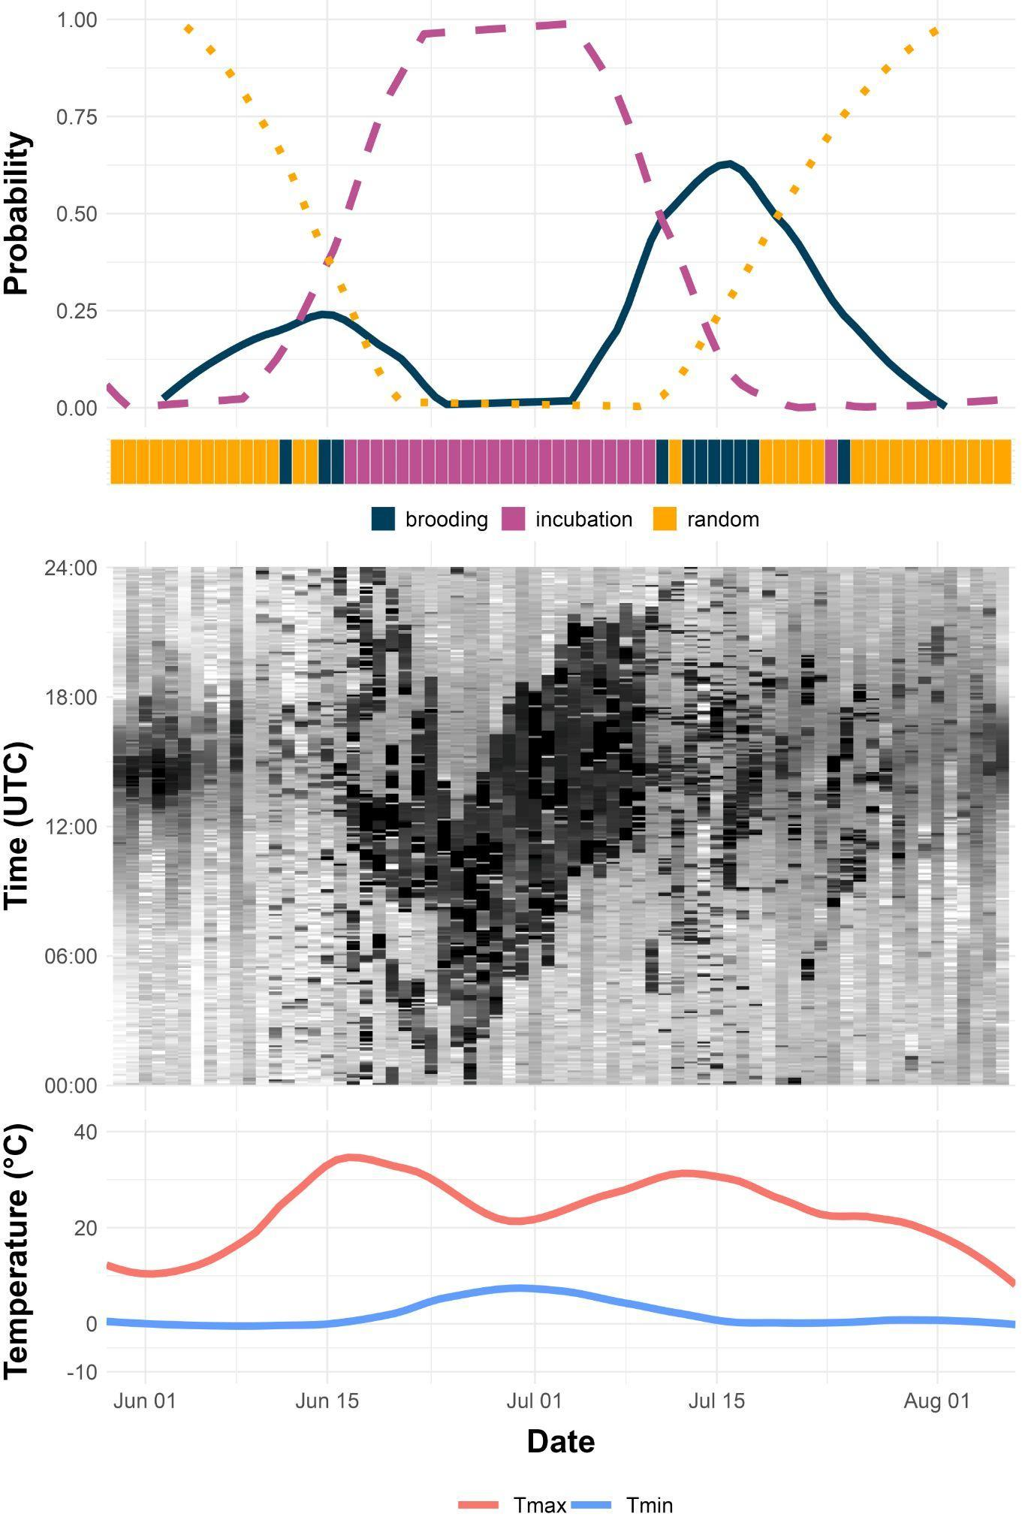
Fig. 2 – Example model predictions and biologger data for Ruddy Turnstones with Logger ID BB959. The top row shows class probabilities for each behavioural category (brooding, incubation, random activity) over time, with predicted classes (highest probability) indicated below the x-axis. The middle row displays light intensity (lux) derived from geolocator data. Shading from dark (low) to white (high) represents recorded light intensity over time. The bottom row shows recorded minimum (blue) and maximum temperatures (red).

Application to other species
Most shorebird species exhibit biparental care (Bulla et al., 2015). Although the duration of incubation bouts may vary among species, the overall structure and temporal patterns of light–dark cycles and temperature fluctuations during incubation are largely comparable. We therefore applied the Ruddy Turnstone model to available datasets from three additional Arctic-breeding shorebird species – the Great Knot (Calidris tenuirostris; Lisovski et al., 2016), Curlew Sandpiper (Calidris ferruginea; Lisovski et al., 2020a), and Red-necked stint (Calidris ruficollis; Lisovski et al., 2020b) – to evaluate its potential generality across related taxa.
Model performance was assessed on preclassified evaluation datasets of each species. For the Great Knot dataset (n = 352 daily samples), the Turnstone model achieved an F1-score (micro) of 0.84, an F1-score (macro) of 0.75, a categorical accuracy of 0.84, and an AUC of 0.88. For the Red-Necked Stint dataset (n = 247 daily samples), the Turnstone model achieved an F1-schore (micro) of 0.99, an F1-sore (macro) 0.97, a categorical accuracy of 0.97, and an AUC of 0.99. For the Curlew Sandpiper dataset (n = 534 daily samples), the Turnstone model achieved an F1-schore (micro) of 0.97, an F1-sore (macro) 0.97, a categorical accuracy of 0.99, and an AUC of 0.99.

Discussion
Here, we present a deep learning approach to analyse breeding behaviour from light-level geolocator data. By combining derived light and temperature data exemplarily from a long-term dataset of Ruddy Turnstones (Arenaria interpres) with a convolutional neural network, we demonstrate that complex behavioural patterns can be objectively identified under Arctic conditions, where direct field observations are rarely feasible. The developed Ruddy Turnstone model showed high predictive performance, accurately distinguishing incubation from brooding and non-breeding related activities (F1-score (micro) = 0.92 ± 0.01, categorical accuracy = 0.92 ± 0.01, AUC = 0.97 ± 0.00).
With NestNetR, we provide an R package offering a reproducible and transferable framework for behavioural inference that can also be applied to other Arctic-breeding species. The approach reduces manual effort and observer bias while maintaining high accuracy, and illustrates how the use of geolocator-derived data can extend their application beyond migration studies. With the integration of potential post-processing procedures, classification accuracy could likely be improved even further. Together, these developments provide a proof of concept for the broader use and potential of deep learning in large-scale ecological analyses.

References
Abdullayev, T. (2024). kerastuneR: Interface to ‘Keras Tuner’. https://CRAN.R-project.org/package=kerastuneR
Borowiec, M. L., Dikow, R. B., Frandsen, P. B., McKeeken, A., Valentini, G., & White, A. E. (2022). Deep learning as a tool for ecology and evolution. Methods in Ecology and Evolution, 13(8), 1640–1660. https://doi.org/10.1111/2041-210X.13901
Both, C., Bouwhuis, S., Lessells, C. M., & Visser, M. E. (2006). Climate change and population declines in a long-distance migratory bird. Nature, 441(7089), 81–83. https://doi.org/10.1038/nature04539
Both, C., Van Turnhout, C. A. M., Bijlsma, R. G., Siepel, H., Van Strien, A. J., & Foppen, R. P. B. (2009). Avian population consequences of climate change are most severe for long-distance migrants in seasonal habitats. Proceedings of the Royal Society B: Biological Sciences, 277(1685), 1259–1266. https://doi.org/10.1098/rspb.2009.1525
Brodrick, P. G., Davies, A. B., & Asner, G. P. (2019). Uncovering ecological patterns with convolutional neural networks. Trends in Ecology & Evolution, 34(8), 734–745. https://doi.org/10.1016/j.tree.2019.03.006
Bulla, M., Cresswell, W., Rutten, A. L., Valcu, M., & Kempenaers, B. (2015). Biparental incubation-scheduling: No experimental evidence for major energetic constraints. Behavioral Ecology, 26(1), 30–37.
Bulla, M., Valcu, M., Dokter, A. M., Dondua, A. G., Kosztolányi, A., Rutten, A. L., Helm, B., Sandercock, B. K., Casler, B., Ens, B. J., Spiegel, C. S., Hassell, C. J., Küpper, C., Minton, C., Burgas, D., Lank, D. B., Payer, D. C., Loktionov, E. Y., Nol, E., … Kempenaers, B. (2016). Unexpected diversity in socially synchronized rhythms of shorebirds. Nature, 540(7631), 109–113. https://doi.org/10.1038/nature20563
Burger, J., Niles, L. J., Porter, R. R., & Dey, A. D. (2012). Using Geolocator Data to Reveal Incubation Periods and Breeding Biology in Red Knots Calidris Canutus Rufa. Wader Study Group Bull., 119(1), 26–36.
Carey, C. (2009). The impacts of climate change on the annual cycles of birds. Philosophical Transactions of the Royal Society B: Biological Sciences, 364(1534), 3321–3330. https://doi.org/10.1098/rstb.2009.0182
Chollet, F. & et al. (2015). Keras. https://keras.io
Cramp, S., Simmons, K. L., Brooks, D., Collar, N., Dunn, E., Gillmor, R., Hollom, P., Hudson, R., Nicholson, E., Ogilvie, M., & et al. (1983). Handbook of the birds of Europe, the Middle East and North Africa. The birds of the Western Palearctic: 3. Waders to gulls.
Gosbell, K., Minton, C., & Fox, J. (2012). Geolocators reveal incubation and re-nesting characteristics of Ruddy Turnstones Arenaria interpres and Eastern Curlews Numenius madagascariensis. Wader Study Group Bull., 119(3), 160–171.
Grandini, M., Bagli, E., & Visani, G. (2020). Metrics for Multi-Class Classification: An Overview (No. 2008.05756). arXiv. https://doi.org/10.48550/arXiv.2008.05756
Huang, X., Zhao, Y., & Liu, Y. (2021). Using light-level geolocations to monitor incubation behaviour of a cavity-nesting bird Apus apus pekinensis. Avian Research, 12(1), 9. https://doi.org/10.1186/s40657-021-00245-w
IPCC. (2023). Climate Change 2023: Synthesis report (First). Intergovernmental Panel on Climate Change (IPCC). https://doi.org/10.59327/IPCC/AR6-9789291691647
Kalinowski, T., Allaire, J. J., & Chollet, F. (2025). keras3: R Interface to ‘Keras’. https://doi.org/10.32614/CRAN.package.keras3
Keitt, T. H., & Abelson, E. S. (2021). Ecology in the age of automation. Science, 373(6557), 858–859. https://doi.org/10.1126/science.abi4692
Kuhn & Max. (2008). Building Predictive Models in R Using the caret Package. Journal of Statistical Software, 28(5), 1–26. https://doi.org/10.18637/jss.v028.i05
Lameris, T. K., Scholten, I., Bauer, S., Cobben, M. M. P., Ens, B. J., & Nolet, B. A. (2017). Potential for an Arctic‐breeding migratory bird to adjust spring migration phenology to Arctic amplification. Global Change Biology, 23(10), 4058–4067. https://doi.org/10.1111/gcb.13684
Lameris, T. K., van der Jeugd, H. P., Eichhorn, G., Dokter, A. M., Bouten, W., Boom, M. P., Litvin, K. E., Ens, B. J., & Nolet, B. A. (2018). Arctic geese tune migration to a warming climate but still suffer from a phenological mismatch. Current Biology, 28(15), 2467–2473.
Li, L., Jamieson, K., DeSalvo, G., Rostamizadeh, A., & Talwalkar, A. (2018). Hyperband: A Novel Bandit-Based Approach to Hyperparameter Optimization (No. arXiv:1603.06560). arXiv. https://doi.org/10.48550/arXiv.1603.06560
Liebezeit, J. R., Gurney, K. E. B., Budde, M., Zack, S., & Ward, D. (2014). Phenological advancement in arctic bird species: Relative importance of snow melt and ecological factors. Polar Biology, 37(9), 1309–1320. https://doi.org/10.1007/s00300-014-1522-x
Lisovski, S. (2018). Light-level geolocation in polar regions with 24-hour daylight. Wader Study, 125(2), 1–6. https://doi.org/10.18194/ws.00109
Lisovski, S., Gosbell, K., Hassell, C., & Minton, C. (2016). Tracking the full annual-cycle of the Great Knot Calidris tenuirostris, a long-distance migratory shorebird of the East Asian-Australasian Flyway. Wader Study, 123(3), 177–189. https://doi.org/10.18194/ws.00048
Lisovski, S., Gosbell, K., Minton, C., & Klaassen, M. (2020a). Data from: Migration strategy as an indicator of resilience to change in two shorebird species with contrasting population trajectories [curlew sandpipers] [Data set]. Movebank Data Repository. https://doi.org/10.5441/001/1.g2n3ps20
Lisovski, S., Gosbell, K., Minton, C., & Klaassen, M. (2020b). Data from: Migration strategy as an indicator of resilience to change in two shorebird species with contrasting population trajectories [red-necked stints] [Data set]. Movebank Data Repository. https://doi.org/10.5441/001/1.s07tk38d
Lisovski, S., & Hahn, S. (2012). GeoLight—Processing and analysing light-based geolocator data in R. Methods in Ecology and Evolution, 3(6), 1055–1059. https://doi.org/10.1111/j.2041-210X.2012.00248.x
Lisovski, S., Hoye, B. J., Conklin, J. R., Battley, P. F., Fuller, R. A., Gosbell, K. B., Klaassen, M., Benjamin Lee, C., Murray, N. J., & Bauer, S. (2024). Predicting resilience of migratory birds to environmental change. Proceedings of the National Academy of Sciences, 121(19), e2311146121. https://doi.org/10.1073/pnas.2311146121
Loktionov, E. Y., Tomkovich, P. S., & Porter, R. R. (2015). Study of incubation, chick rearing and breeding phenology of Red Knots Calidris canutus rogersi in sub-Arctic Far Eastern Russia aided by geolocators. Wader Study, 122(2). https://doi.org/10.18194/ws.00012
Nathan, R., Monk, C. T., Arlinghaus, R., Adam, T., Alós, J., Assaf, M., Baktoft, H., Beardsworth, C. E., Bertram, M. G., Bijleveld, A. I., Brodin, T., Brooks, J. L., Campos-Candela, A., Cooke, S. J., Gjelland, K. Ø., Gupte, P. R., Harel, R., Hellström, G., Jeltsch, F., … Jarić, I. (2022). Big-data approaches lead to an increased understanding of the ecology of animal movement. Science, 375(6582), eabg1780. https://doi.org/10.1126/science.abg1780
Nettleship, D. N. (1973). Breeding ecology of Turnstones Arenaria interpres at Hazen Camp, Ellesmere Island, NWT. Ibis, 115(2), 202–217.
Parmelee, D. F., & MacDonald, S. (1960). The birds of west-central Ellesmere Island and adjacent areas. Department of Northern Affairs and National Resources.
Post, E., Forchhammer, M. C., Bret-Harte, M. S., Callaghan, T. V., Christensen, T. R., Elberling, B., Fox, A. D., Gilg, O., Hik, D. S., Høye, T. T., Ims, R. A., Jeppesen, E., Klein, D. R., Madsen, J., McGuire, A. D., Rysgaard, S., Schindler, D. E., Stirling, I., Tamstorf, M. P., … Aastrup, P. (2009). Ecological Dynamics Across the Arctic Associated with Recent Climate Change. Science, 325(5946), 1355–1358. https://doi.org/10.1126/science.1173113
Schaub, T., Wellbrock, A. H. J., Rozman, J., & Witte, K. (2019). Light data from geolocation reveal patterns of nest visit frequency and suitable conditions for efficient nest site monitoring in Common Swifts Apus apus. Bird Study, 66(4), 519–530. https://doi.org/10.1080/00063657.2020.1732862
Serreze, M. C., & Barry, R. G. (2011). Processes and impacts of Arctic amplification: A research synthesis. Global and Planetary Change, 77(1–2), 85–96. https://doi.org/10.1016/j.gloplacha.2011.03.004
Terven, J., Cordova-Esparza, D.-M., Romero-González, J.-A., Ramírez-Pedraza, A., & Chávez-Urbiola, E. A. (2025). A comprehensive survey of loss functions and metrics in deep learning. Artificial Intelligence Review, 58(7), 195. https://doi.org/10.1007/s10462-025-11198-7
van Gils, J. A., Lisovski, S., Lok, T., Meissner, W., Ozarowska, A., de Fouw, J., Rakhimberdiev, E., Soloviev, M. Y., Piersma, T., & Klaassen, M. (2016). Body shrinkage due to Arctic warming reduces red knot fitness in tropical wintering range. Science, 352(6287), 819–821. https://doi.org/10.1126/science.aad6351
Visser, M. E., Both, C., & Lambrechts, M. M. (2004). Global Climate Change Leads to Mistimed Avian Reproduction. In Advances in Ecological Research (Vol. 35, pp. 89–110). Elsevier. https://doi.org/10.1016/S0065-2504(04)35005-1
Wotherspoon, S., Sumner, M., & Lisovski, S. (2016). TwGeos: Basic data processing for light-level geolocation archival tags. R Package.

Acknowledgements
This project was partly funded by the Australian National Environmental Science Program (NESP 4.26: Modelling shorebird migration to assess disease risk amid global change). We gratefully acknowledge the long-term efforts of volunteers and collaborators from the Victorian Wader Study Group (VWSG) and the Australasian Wader Studies Group (AWSG) in collecting and maintaining the geolocator datasets. Particularly, we thank Marcel Klaassen, Ken Gosbell, Clive Minton, Maureen Christie, Roz Jessop and Chris Hassell. B.P.S. was supported by a PhD scholarship from the Deutsche Bundesstiftung Umwelt (DBU).

Author contributions
B.S. and S.L. conceived the ideas and designed methodology. M.K. and S.L. collected the data. B.S. analysed the data. B.S. drafted the manuscript. All authors contributed to the writing and gave final approval for publication.



Supplementary Material

A – Model Performance
Table A1 – Deep learning model performance tested on various sizes of Training data (10 – 100%). Metrics are denoted as estimated mean score ± SD over ten independent training runs for each training data size scenario. Reported metrics are F1-score (micro and macro), categorical accuracy, and area under the curve (AUC).
Training data size | F1-score (micro) | F1-score (macro) | Cat. Accuracy | AUC
100%  (final model) | 0.92 ± 0.01 | 0.84 ± 0.01 | 0.92 ± 0.01 | 0.97 ± 0.00
90% | 0.91 ± 0.01 | 0.82 ± 0.01 | 0.91 ± 0.01 | 0.97 ± 0.00
80% | 0.91 ± 0.01 | 0.82 ± 0.01 | 0.91 ± 0.01 | 0.97 ± 0.00
70% | 0.90 ± 0.02 | 0.81 ± 0.02 | 0.90 ± 0.02 | 0.97 ± 0.00
60% | 0.89 ± 0.01 | 0.79 ± 0.02 | 0.89 ± 0.01 | 0.97 ± 0.00
50% | 0.89 ± 0.02 | 0.79 ± 0.02 | 0.89 ± 0.02 | 0.97 ± 0.00
40% | 0.88 ± 0.01 | 0.77 ± 0.02 | 0.88 ± 0.01 | 0.96 ± 0.01
30% | 0.87 ± 0.02 | 0.75 ± 0.03 | 0.87 ± 0.02 | 0.96 ± 0.01
20% | 0.86 ± 0.02 | 0.73 ± 0.02 | 0.86 ± 0.02 | 0.96 ± 0.00
10% | 0.86 ± 0.02 | 0.74 ± 0.04 | 0.86 ± 0.02 | 0.96 ± 0.01

Table A2 – Deep learning model performance tested under varying levels of class balance in the training data. Performance metrics are shown as estimated mean ± SD across ten independent training runs for each scenario. Reported metrics include the F1-score (micro and macro), categorical accuracy, and area under the curve (AUC). All models were trained on datasets of equal total size (n = 474) but with different class distributions: “Balanced” (equal proportions of all classes), “Mild” (brooding = 20%, incubation = 40%, random = 40%), “Moderate” (brooding = 15%, incubation = 30%, random = 55%), and “Natural” (brooding = 12%, incubation = 35%, random = 53%; reflecting more natural class imbalance in the dataset).
Class balance scenario | F1-score (micro) | F1-score (macro) | Cat. Accuracy | AUC
Balanced | 0.75 ± 0.02 | 0.70 ± 0.01 | 0.75 ± 0.02 | 0.92 ± 0.01
Mild | 0.83 ± 0.01 | 0.75 ± 0.01 | 0.83 ± 0.01 | 0.95 ± 0.00
Moderate | 0.84 ± 0.01 | 0.77 ± 0.01 | 0.84 ± 0.01 | 0.96 ± 0.01
Natural | 0.85 ± 0.01 | 0.74 ± 0.01 | 0.85 ± 0.01 | 0.95 ± 0.01

Table A3 – Deep learning model performance variable combinations. Performance metrics are shown as estimated mean ± SD across ten independent training runs for each scenario. Reported metrics include the F1-score (micro and macro), categorical accuracy, and area under the curve (AUC).
Variable set | F1-score (micro) | F1-score (macro) | Cat. Accuracy | AUC
Light + Tmin + Tmax | 0.87 ± 0.01 | 0.76 ± 0.01 | 0.87 ± 0.01 | 0.95 ± 0.00
Raw Light + Tmin + Tmax | 0.81 ± 0.01 | 0.69 ± 0.02 | 0.81 ± 0.01 | 0.93 ± 0.00
Light | 0.87 ± 0.01 | 0.78 ± 0.02 | 0.87 ± 0.01 | 0.97 ± 0.00
Raw Light | 0.87 ± 0.01 | 0.76 ± 0.01 | 0.87 ± 0.01 | 0.95 ± 0.00
Light + Tmin | 0.87 ± 0.01 | 0.79 ± 0.01 | 0.87 ± 0.01 | 0.95 ± 0.01
Light + Tmax | 0.86 ± 0.01 | 0.74 ± 0.01 | 0.86 ± 0.01 | 0.96 ± 0.01
Raw Light + Tmin | 0.83 ± 0.01 | 0.71 ± 0.01 | 0.83 ± 0.01 | 0.95 ± 0.00
Raw Light + Tmax | 0.82 ± 0.02 | 0.68 ± 0.02 | 0.82 ± 0.02 | 0.93 ± 0.01

